F

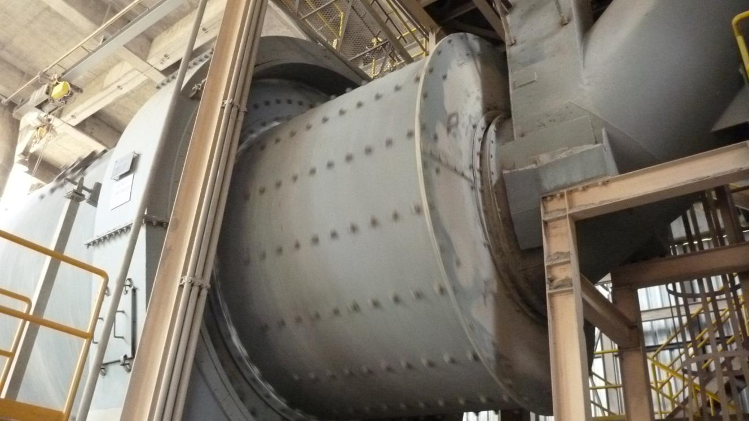F

**Table of Contents**

**Table of Contents**

**Manual: Heat Balance of Grinding Systems**

**1.** **Introduction**

1.1 Advantages and Disadvantages of the HB Tool

1.2 Aim and Structure of this Manual

1.3 References

1.4 Download the Tool

**2.** **Precautions with Excel**

**3.** **Overview of the Excel Tool**

3.1 Colour Coding of Cells

3.2 Available Excel Sheets

3.3 The ‘RMBIL’ Sheet

3.3.1 Short-cuts from Input/Output Table

3.3.2 Short-cuts from the Flowsheet

3.4 Input File

**4.** **Definition of the Grinding System**

4.1 Available Mill Models

4.2 UserForm: ‘System’ Tab

4.2.1 2- or 3-Fan System

4.2.2 Gas Recirculation to the Mill

4.2.3 Cooling Tower

4.2.4 Cooler Air Addition

4.2.5 Gas to Coal Mill

4.2.6 Gas to Mill

4.2.7 Feed Composition based on Wet or Dry

4.2.8 Varia Tick Options

4.3 UserForm: ‘Mill and Separator’ Tab

4.4 UserForm: ‘HGG’ (Hot Gas Generator) Tab

**5.** **Linking Theory and Reality**

5.1 Reasons for doing a Mill Heat Balance

5.2 Basic Steps of a Theoretical Heat Balance

5.3 Heat Balance Programmed in the HB Excel Tool

5.4 How to Bring Together Reality and Theory with the HB Excel Tool

5.4.1 Excess Gas Flow

5.5 Assumptions in the HB Excel Tool

5.6 Conventions in the HB Excel Tool

**6.** **Input and Output Data incl. Guide Values**

6.1 Title Block

6.2 Identification of Plant, Equipment and Author

6.3 General Technical Information

6.4 Feed and Product

6.5 Specific Energy Consumption and Efficiencies (Mill, Separator, Fans)

6.6 Cooling Tower (Water Injection and Outlet Temperature)

6.7 False Air Rates

6.8 Flow Rates and Temperatures in Mill and Separator

6.9 HB of 1st and 2nd Compartment 1

6.10 Kiln

6.11 Miscellaneous

6.12 Available Gases

6.13 Gas Flows

6.14 Varia

**7.** **Annex**

7.1 GV: Efficiencies of Drives

7.2 GV: Cp Values of Gases, Solids and Coal

7.3 Flowcharts of 2 and 3-fan systems

**Notation**

|  |  |
| --- | --- |
| AS | Air Swept |
| BM | Ball Mill |
| CT | Cooling (=Conditioning) Tower |
| EDCD | End Discharge/Center Discharge |
| FA | False Air |
| GV | Guide Value |
| HB | Heat Balance |
| HGG | Hot Gas Generator |
| PH | Pre-Heater |
| VRM | Vertical Roller Mill |
| w | wet, (e.g. in Nm3 w) |

**Manual:  
Heat Balance of Grinding Systems**

# Introduction

Over the past years, an Excel-based tool has been created to perform heat balances of grinding systems. In the HTEC Grinding Group, we often refer to this tool as just the ‘heat balance’ (HB).

It is a quite powerful tool, but it takes some time to get used to it.

## Advantages and Disadvantages of the HB Tool

Compared to hand calculations, this Excel-based HB tool has/is:



All these advantages come at the cost of

* loss in flexibility
* increased complexity

## Aim and Structure of this Manual

This manual shall help you to familiarize with this tool and to use it in a correct and efficient way.

The first chapter after the introduction lists the known precautions which have to be taken with the Excel tool in order to keep in functional. The next chapter gives an overview of the user interfaces. The chapter thereafter explains the options available for modelling your grinding system with this HB Excel tool. The following chapter tries to link the reality with the tool by e.g. mentioning the assumptions and mathematical models. The last chapter lists the input and output variables with some explanation and guide values.

## References

It is not the aim of this manual to provide general information about heat balances or grinding systems. For such information, you may refer to the documents on the global intranet:



Figure 1: Access to the Grinding Technology community on iShare.

In the section ‘manual’ of ‘grinding technology’, information about HB in grinding system can be found in the chapters ‘Cooling and Heating’ as well as in ‘Drying Technology’, see Figure 2.

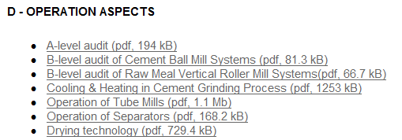

Figure 2: Printscreen of the Grinding Manual in the Holcim Portal. Chapters with information about the HB are highlighted.

## Download the Tool

You may download the HB Excel-tool from the Holcim portal: In the Grinding Community (see Figure 2), there are three HB files ready to download, as shown in Figure 3.’

|  |  |
| --- | --- |
|  |  |

Figure 3: HB Excel-tool on the Holcim Portal, available for download.

# Precautions with Excel

The HB Excel-tool is sensitive. Depending on the Excel version and your computer environment, some of the following precautions/actions may be necessary:

* **Close other files:**  
  While working with the Excel HB, keep all other Excel files and Lotus Notes closed.
* **Macros:**  
  Macros must be enabled when opening the workbook.
* **Comma, vs decimal point:**  
  The heat balance excel sheet uses decimal point. In Excel 2010, you may change your settings from the Windows Start Menu -> Control Panel -> Region and Language -> Formats tab -> Advanced Settings -> Number tab -> Decimal Symbol.  
  Alternatively, try in Excel -> File -> Options -> Advanced -> untick ‘Use system separators’ and insert a point in the field ‘Decimal separator’.
* **Unprotect worksheet** (no password required):  
  Excel 2010: Review → unprotect worksheet.  
  Older Excel versions: Tools → Protection → unprotect worksheet.
* **Number of Iterations** must be ≥ 50:  
  Excel 2010: File → Options → Formulas → Workbook Calculation: …   
  Older Excel versions: Tools → Options → Calculation:…  
  … then ‘Automatic’ and ‘enable iteration’, see Figure 4.  
  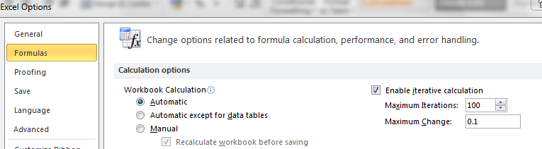
* **‘RMBIL’ to be the first spreadsheet** in the workbook,   
  otherwise the flowsheet update will not work and the worksheet name in line 6, 7 and 11 is wrong.
* **‘RMBIL’ to be the active spreadsheet** when closing or saving the workbook,   
  otherwise, an error may occur when reopening the workbook.
* **In the flowsheet:**  
  Do not change cell width or height and do not delete or add any lines or other graphical elements. Colouring in white or adding white areas however is OK.

**Hint – save corrupted calculation**

If your Excel HB got corrupted, you may try to save the input data (see section 3.4) and reload it from a new Excel HB sheet.  
If this does not work, it is very often faster to restart with a new file and retype the input data instead of looking for the error.

# Overview of the Excel Tool

## Colour Coding of Cells

The colours of the cells indicate:

|  |  |
| --- | --- |
| blue on yellow: | input field: to be filled in by user. |
| black on white: | calculated value / indication |
| red on white | warning or hint |

**Hint – Comments/Helps to Cells**

Cells with a red triangle in the upper right corner () often contain valuable remarks to the user. The text becomes visible by hovering with the curser above it.

## Available Excel Sheets

The Heat Balance Excel workbook consists of three sheets:

* **‘RMBIL’:**   
  This is the main sheet and is described in detail in the remaining part of this document. It contains all input and output data, as well as intermediate results, in Excel tables. Additionally, the most important data is visualized in a flowsheet.
* **‘Help’:**Explains the usage of the HB tool. This HB Manual is a quite extended version of the ‘Help’ sheet.
* **‘VA-1744’:**  
  Contains data of specific gas flow, heat consumption and temperature in the preheater. (HTEC - TT-document. It provides guide values, only for information, not used for calculation.)

**Hint – Several ‘RMBIL’ sheets in one workbook**

It is possible to have several ‘RMBIL’ sheets in one workbook. To add an additional RMBIL, rightclick on the the tab and choose ‘copy’ from the menu.

In the VRM HB, there is an additional sheet

* **‘heatloss_ducts’:**  
  Gives guide values and formulas to estimate the heat loss through the walls of isolated ducts.

## The ‘RMBIL’ Sheet

This section explains features and content of the ‘RMBIL’ sheet. This section purely treats handling of the tool and does not give information about thermodynamics, calculation or guide values, since these topics are treated in separate chapters.

The Figure 5 shows print screens of the ‘RMBIL’ sheet in the sequence as they appear in the Excel sheet. The aim of this figure is to give an overview of the content and of the arrangement of the various elements. In the same figure, a short description of the elements and cross-references to the sections containing more details, when available, are given.

|  |  |  |  |  |
| --- | --- | --- | --- | --- |
| Screenshots of the ‘RMBIL’ sheet | | | | Elements of ‘RMBIL’ |
|  | | | | 1. Title block with automatic generated title and general data about the plant and the author. 2. Short-cuts to various functions as described in section 3.3.1. 3. Important hints and conventions. 4. Space to add notes by user. |
|  | | 1. a+b: Input area and the results.  For the colour coding of the cells, see 3.1. The input fields together with guide values are discussed in chapter 5. | | |
|  | | 1. Summary of the heat balance.  The energy input and output flows are summarized and the absolute as well as the relative contribution to the total energy flow are shown. Further information is given in section 5.4.1. | | |
| […] | | | 1. Intermediate results. Many intermediate results, such as dedicated tables for gas flows of each of the grinding system configurations (e.g. CT before kiln fan, …), more details about the heat balance, the HGG calculation, the userform variables, … | |
| […] | | | 1. Table containing the translations of the HB words into different languages. | |
| 1. The header of the flowsheet contains - short-cuts (see section 3.3.2) - summary of the chosen system configuration options 2. The flowsheet gives a good overview of the system and the parameters. The system configuration options are visualized and details of material and gas flows are shown.   Use the button ‘Update Flowsheet’ to make sure the most recent values and configuration is shown. |  | | | |

Figure 5: Print screens and explanations of the 'RMBIL' sheet.

**Hint – System Configuration Number**

On the right side of area, the chosen configuration options of the system are indicated. There is also a ‘case number’. This case number allows identifying the relevant table in area  for the gas flows.

### Short-cuts from Input/Output Table

The buttons shown in Figure 6 allow to easily execute the following commands as further explained in Figure 7.

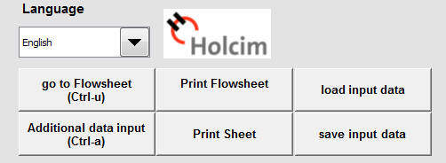

Figure 6: Short-cuts in the input and output sheet 'RMBIL'

|  |  |  |
| --- | --- | --- |
|  | Function | Comment / Illustration |
|  | Choose any of the available languages.  The entire sheet is immediately translated. | The translated expressions are visible from cell B427 on. |
|  | Sends you to the flowsheet which is placed further down in the same sheet.  A sample flowsheet is shown on the right. |  |
|  | ‘print flowsheet’ opens the printer window, so you may choose printer and settings to print the flowsheet. |
|  | ‘Additional data input’ opens the UserForm where the equipment and connections inside the grinding system can be chosen. Usage of the UserForm is further explained in section 4. |  |
|  | ‘Print Sheet’ is to print the input/output table (see right). It opens the printer window, so, you may choose the printer and settings. |  |
|  | ‘load input data’ allows to load the input data from a text file into the Excel HB. See section 3.4. |  |
|  | ‘save input data’ opens a file explorer, so you may choose name and location of the input data to be saved. See section 3.4.. |

Figure 7: Description of short-cuts in the input and output sheet.

### Short-cuts from the Flowsheet

The header of the flowsheet contains short-cuts as displayed in Figure 8. Figure 9 gives a short description about each of these short-cuts.

|  |
| --- |
|  |

|  |  |  |
| --- | --- | --- |
|  | Function | Comment / Illustration |
|  | ‘go to data entry’ sends you to the cell A1, where the input/output table starts. |  |
|  | ‘additional data input’ same as item ④ in Figure 7. | - |
|  | ‘update flowsheet’ redraws the flowsheet. It makes sure the flowsheet displays the latest information. | - |
|  | ‘print flowsheet’ same as item ③ in Figure 7. | - |

Figure 9: Description of short-cuts in the flowsheet header.

## Input File

Instead of saving different calculations in Excel files (~1 MB), you may store only the input data in a text file of only ~1 kB size without losing any information. This text file is referred to as ‘input file’.

**Hint – ending of input files**

The input files have the following endings, depending on the mill model used:   
- .vrm for the VRM  
- .edm for the EDCD BM  
- .asm for the AS BM

To create this file, enter the input data into the Excel file and then use the button ‘save input data’.

To continue working on a calculation from such a file, use the button ‘load input data’. Both of these buttons are located at the top right of the input/output table, see item ② of Figure 6.

Figure 10 shows the user form which appears to save the input file. The table in Figure 11 gives some further explanation.

|  |  |
| --- | --- |
|  | Shows your current location. I.e. if you press ‘save’ now, your file will be stored here. |
|  | This is the navigation window. To move up one level of folders, double click on ‘[..]’ and to move to a subfolder, double-click on this folder. |
|  | Shows only the files of the input file type (e.g. ‘.vrm’) of the current folder.  If you want to replace an existing file, chose it from this window. |
|  | If you want to save the file under a new name, enter the name in this window. |
|  | Save or cancel. |

Figure 11: Areas of the 'save input file' userform.

**Hint – storage location for files**

Problems may occur if you save the files in ‘D:\\users\username\My Documents\..’. There may be some more problematic places which have not been discovered up to now. You may save the file e.g. in D:\\users\username\Documents\...’

# Definition of the Grinding System

## Available Mill Models

The HB for the following three grinding systems were programmed in distinct Excel files:

* VRM
* Centre-discharge and end discharge BM
* Air-swept BM

When opening one of the above Excel files, a pop-up window ‘UserForm1’ appears (see Figure 12). In this window, there are three tabs (‘System’, ‘Mill and Separator’, ‘HGG’). You can further define the grinding system as described in the following sections.

**Hint – manipulation of system configuration**

All the definitions and inputs in the user form can also be done by manipulating the respective cells in the worksheet. In the ‘help’ worksheet, the corresponding cells, options and values are indicated.

## UserForm: ‘System’ Tab

Figure 12 shows the ‘System’ tab of the UserForm1. This form allows defining the connections/gas streams between the equipment, as far as not defined by the other two tabs of the UserForm1.

There are a lot of different combinations possible.

**Hint – use flowsheet to check sequence of gas streams and equipment**

The sequence of gas streams and equipment affects the resulting gas mix and temperature. Use the flowsheet to make the final check how the gas streams and equipment are placed with respect to each other.

**Hint – choices affect each other**

An option may become unavailable or change because of another choice made.   
E.g. if there is a cooling tower, the ‘gas to coalmill’ connection is placed with respect to the cooling tower. If there is no cooling tower, it is placed with respect to the kiln fan.

**Hint – available options depend on mill model**

Some options are not available for certain mill models because they have not been applied in practice in any Holcim plant.

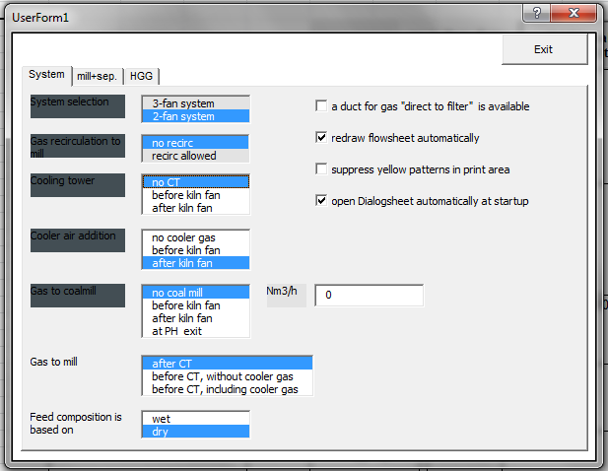

Figure 12: UserForm1 of the centre/end-discharge/ BM HB, showing the System tab.

### 2- or 3-Fan System

See annex 7.3 for flowcharts of the 2- and 3-fan systems for the three available mill types.

As shown in Figure 12, choose one of the following options:

* 2-fan system
* 3-fan system

**Hint – which fans count?**

The following fans are counted:  
- fan upstream mill (ID fan from kiln or clinker cooler)  
- fan(s) downstream mill (mill fan), sucking gas through the mill.

**Attention:** if gas stream through fan is not passing through the mill, then this fan is not counted.

**Hint – no 3-fan system for EDCD BM**

Only the 2-fan system, but not the 3-fan system, is available in the Excel for EDCD BM.

### Gas Recirculation to the Mill

(This option is not available for the EDCD BM)

**Gas recirculation to the mill**   
defines whether gas downstream the mill may flow to the mill entry, see Figure 13.

As shown in Figure 12, choose one of the following options about the gas recirculation to the mill:

* Recirculation allowed
* No recirculation

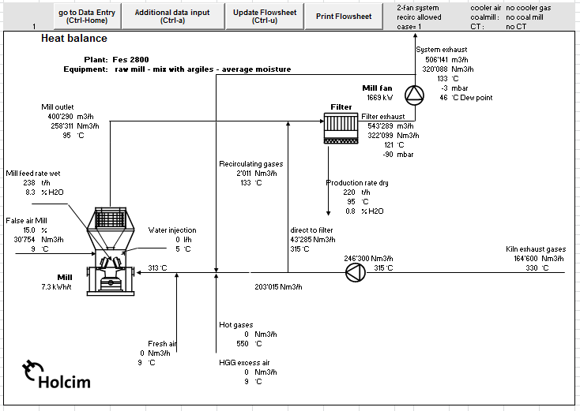

Figure 13: Flowchart for VRM HB. The recirculating line is highlighted.

### Cooling Tower

**Cooling Tower**   
The cooling tower in the HB Excel Tool is a device used to cool down gas coming from the kiln area. It may represent other devices than cooling towers in the real plant, such as downcomer water injection or fresh air cooling,

Usually, the filters are the most heat sensitive elements in a grinding system. If the mill is shut down and the kiln is running, the gas has to be cooled down by the cooling tower before being sent to the filter.

This option defines whether there is a cooling (conditioning) tower and where it is located with respect to the kiln fan. As shown in Figure 12, you may choose a model with

* No CT
* CT before kiln fan
* CT after kiln fan

Figure 14 illustrates the available options.

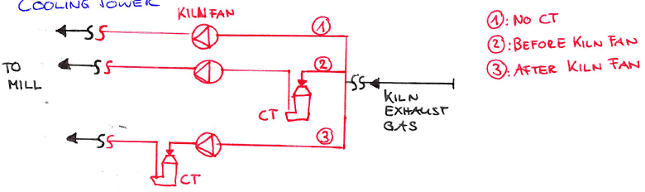

Figure 14: Available options (red) for placing the cooling tower.

### Cooler Air Addition

**Cooler Air**   
The cooler exhaust air from the clinker cooler is hot and may be used for drying.

The heat balance tool allows (see Figure 12) including a stream of cooler air as follows:

* No Cooler Gas
* Before Kiln Fan (or Cooling Tower, if there is one)
* After Kiln Fan (or Cooling Tower, if there is one)

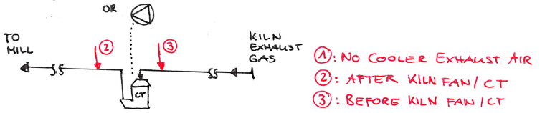

Figure 15: Available options (red) for where to add cooler exhaust air.

### Gas to Coal Mill

**Gas to Coal Mill**   
Gas may be deviated from the gas stream to the mill to use it for drying in the coal mill.

As shown in Figure 12, you may choose a model with

* No coal mill
* Before kiln fan/cooling tower
* After kiln fan/cooling tower
* After the PH tower

Left to the multiple choice selection, indicate how much flow is deviated to the coal mill.

**Hint – why is it so important to set the kiln gas temperature right?**   
Option 2 and 4 look the same in the flow sheet (see Figure 16). The difference is as follows:

- Option 2 (gas to coal mill before kiln fan/CT): the gas to the coal mill is taken directly upstream the kiln fan, after CT. So, in case the raw mill is not running, the gas to the coal mill is affected due to the water injection into the downcomer.   
- Option 4 (gas to coal mill after the PH tower): the coal mill has an own gas supply duct from the PH top down to the coal mill inlet, without passing through any cooling device. This means, that the coal mill has always the same temperature, even if the raw mill is shut off.

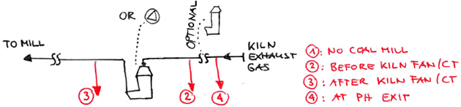

Figure 16: Available options (red) for where to take away gas for the coal mill.

### Gas to Mill

**Gas to mill**

Only if there is a CT, you may choose whether the mill inlet gas stream passes through the CT before entering the mill, or not.

As shown in Figure 12, you may choose from the following options:

* After CT
* Before CT, without cooler gas
* Before CT, with cooler gas

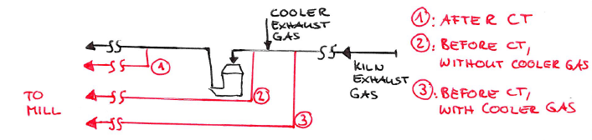

Figure 17: Gas to Mill

**Hint – unlock listboxes**

If ‘gas to mill’ is drawn ‘before CT’, some of the earlier options are set to their default values and will be locked in their respective listboxes. To unlock these listboxes, select ‘gas to mill’ as ‘after CT’.

### Feed Composition based on Wet or Dry

The composition [%] of the feed you enter (see section 6.4) may either base on wet or dry portions.

As shown in Figure 12, you may make your choice here. In the data input sheet, this will be reflected in the header by ‘composition % (dry)’ or ‘composition % (wet)’ respectively. ‘Composition % (wet)’ is the option commonly used for mill assessments, where massflows are taken from the weigh feeder counters. ‘Composition % (dry)’ is the option often used for design purposes.

### Varia Tick Options

As shown in Figure 12 on the right, there are various tick options.

|  |  |
| --- | --- |
| Tick Option | Effect |
| **Hint – limited use** This option may be checked only for raw mills with recirculation and if more kiln gas is available than is required for drying. For coal mills or cement mills however, there is no such duct to the process filter, and therefore this iteration loop must be skipped.  In this case, the available amount of kiln and cooler gas must then be adjusted manually such that gas flow direct to filter (excess gas) is zero | if ☒: gas duct upstream mill inlet (from kiln) directly to filter is available. In this case, it is assumed that excess kiln + cooler gas are not required for drying, so these gases go directly to the filter.  if □: this gas duct goes directly to the mill |
|  | Option not needed. Flowsheet is redrawn automatically in any case. |
|  | if ☒: when the spreadsheet is printed, there are no yellow cells.  if □: the spreadsheet is printed in the way it is shown on the screen. |
|  | Option not needed. In any case, ‘UserForm1’ pops-up when the spreadsheet is opened. |

**Hint – gas duct for gas ‘direct to filter’**

Normally, a gas duct ‘direct to filter’ is standard for raw mills, but not present in coal-, cement and slag mills.

## UserForm: ‘Mill and Separator’ Tab

This tab is different for each of the three heat balance models, as shown in Figure 17.

* For the EDCD BM, the type of mill (ED or CD), the separator type (1st, 2nd, 3rd generation) and the separator arrangement (internal fan, cyclone air or single pass separator) need to be defined.  
  The 1st generation separator goes automatically together with the separator arrangement ‘internal fan’. For the 2nd and 3rd generation separator, the separator arrangement can be either ‘single pass’ or ‘cyclone air’ (see Figure 18).
* For the AS BM, only the type of separator (1st, 2nd, 3rd generation) needs to be chosen.
* For the VRM, there are no options.

|  |  |  |
| --- | --- | --- |
| EDCD BM | AS BM | VRM |
|  |  | not available / necessary |

Figure 18: Mill and separator tab of the three different heat balance models.

|  |  |
| --- | --- |
| Single Pass Separator | Cyclone Air Separator |
|  |  |

Figure 19: Flowsheet of the single pass and the cyclone air separator arrangement.

## UserForm: ‘HGG’ (Hot Gas Generator) Tab

In case of a HGG, enter the fuel and its net calorific value as well as the excess air in the corresponding tab, as shown in Figure 19.

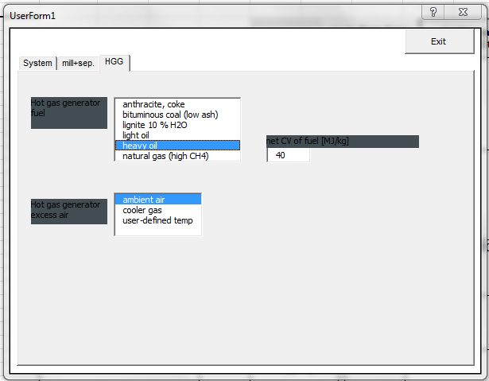

Figure 20: UserForm: Hot gas generator tab.

# Linking Theory and Reality

The aim of this chapter is to establish a link between the theory, the methodology for describing thermodynamic systems, the HB Excel tool and the reality. There is no intention to be exhaustive (e.g., there are no instructions on how to do the practical field work), but just, to give a general idea.

## Reasons for doing a Mill Heat Balance

Reasons for doing a HB are

* Predicting the reality
  + to do dimensioning for a future investment
  + to predict the effects (bottlenecks) of a change in the process (e.g. increase in humidity, production capacity, …)
* Compare theoretical cases and predictions with the reality
  + to check predictions
  + to identify bottle necks
  + to find room for improvement

## Basic Steps of a Theoretical Heat Balance

1. Define boundaries of system and subsystems (example see in Figure 21)
   * For the mass and energy balance of a system, the system itself is a black box. Only the mass and energy flows across the boundaries can be seen / are relevant for the calculation
   * In order to ‘see’ inside the system, it has to be divided into subsystems. Flows which have to be visible have to cut a boundary. Construct your subsystems according your needs.
2. Do the mass balance.
   * Identify all mass streams and chemical reactions.
   * Input = output for the system and all subsystems
   * Input = output for all chemical components
   * Make the necessary assumptions
   * Solve
   * Cross-check, analyse and interpret solution
3. Do the energy balance
   * Identify all energy streams
   * Input = output for the system and all subsystems
   * Make the necessary assumptions
   * Solve
   * Cross-check, analyse and interpret solution
4. Make sensitivity analyses and question assumptions
   * Which parameters influence the results how much and in which way?
   * To what extent may the assumptions adulterate the results?
5. Draw conclusions.

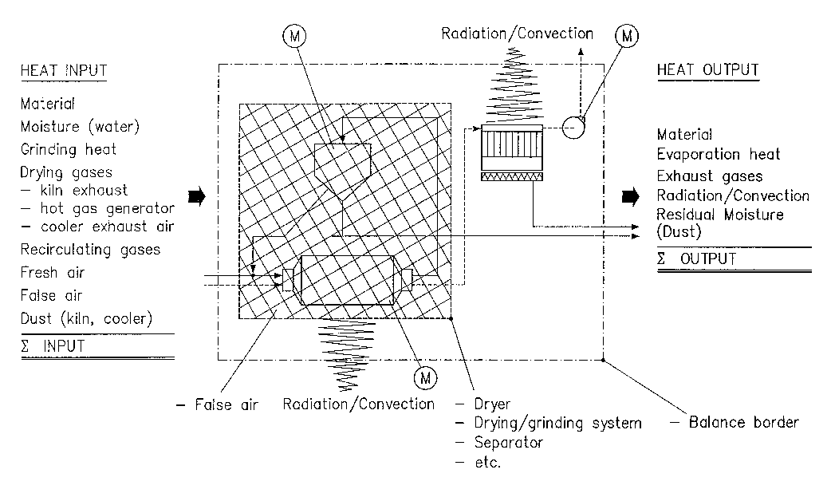

Figure 21: Example of system and subsystem boundaries and energy input and output.

## Heat Balance Programmed in the HB Excel Tool

The system and subsystem boundaries as well as the mass and energy balances are already defined in the HB Excel Tool. These definitions are quite complex, since the HB Excel Tool has to be suitable for many different systems. No graphical representation of these subsystems is tempted in this manual.

What can be said, however, is, that the calculations and the models are quite precise. E.g., the specific heat, cp, is calculated as a function of the temperature and other parameters, such as percentage of volatiles in coal. This is leading to implicit equations, which would not be possible to solve manually.

A summary of the results of the complex calculations done by the HB Excel Tool is shown in lines 79-98 in the ‘RMBIL’ sheet, see Figure 21.

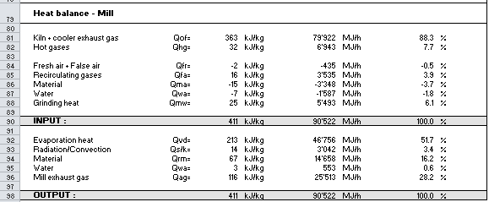

Figure 22: Summary of the main input and output streams, as programmed in the HB Excel Tool.

## How to Bring Together Reality and Theory with the HB Excel Tool

In fact, the HB Excel Tool can be seen as the link between the theory and the reality:   
It contains the mathematical models for the system and subsystems, and the input values from the reality.



Since the mathematical models are simplifications of the reality and since the measurements are afflicted with measurement errors, the theory and the reality normally do not perfectly match.

There are several possibilities to match reality and theory. E.g.

* adjust each or several input values or
* attribute the mismatch to one item.

In the HB Excel tool:

* For the mass balance, the number of unknown variables match the number of equations. The HB Excel tool calculates the feed rate into the mill circuit based on the production rate.
* For the energy balance, there are more equations than unknown. So, an additional degree of freedom has been introduced, which is the flow from the HGG (in case of drying in the mill) or the amount of water injected (in case of cooling). The Excel tool will calculate this flow based on the input values.
* The user may then manipulate the input values in order to adjust the flow from the HGG or the amount of water injected.

### Excess Gas Flow

For a raw mill system with the following three features:  
- two fan system and

- recirculation and

- more kiln gas available than required for drying, there is excess gas which goes directly to the filter via the duct for direct operation.

However, for coal or cement mills, there is no such duct to the process filter. Therefore, the available amount of kiln and cooler gas must be manually adjusted, so that the gas flow direct to filter (excess gas) is zero.

## Assumptions in the HB Excel Tool

Following a list of assumptions

* Steady operation. No transient state can be calculated. This means, if input values come from measurements, these measurements have to be taken during steady operation.
* FA and heat loss between PH exit and CT inlet or kiln fan inlet (whatever is first) are assumed to be zero.
* The wind speed for the calculation of the convection heat loss is assumed to be 0 m/s. The fact that the external surface of a BM rotates, makes estimations of the wind speed very hard. However, in the VRM HB, it would be possible to change the wind speed.
* No chemical reaction is taking place in the mill.
* The motor power at shaft is fully converted into heat which is input into the grinding system.

## Conventions in the HB Excel Tool

Please note the following important conventions used in the HB Excel Tool:

* All sensible heat (enthalpies) refer to +20°C
* All gas flow refer to wet gas
* All oxygen content in the ‘RMBIL’ sheet A1 to I100 refer to dry gas
* Gas humidity refers to wet gas
* Mill dimensions refer to outer dimensions (in contrary to other mill sheets), since they are used for the calculation of the heat loss
* Feed moistures refer to wet material. But feed composition refers to wet or dry material as specified by the user in the userform.

# Input and Output Data incl. Guide Values

The input data is either stored in the HB Excel file or in the input data file which may be imported (see 3.4). By opening an input data file, you may check that there are around 130 input values. They are going to be discussed in the sequence they appear in the input/output table and guide values will be given where possible.

The source of the majority of the content of this chapter is ‘help’ sheet of the Excel HB.

It is assumed, that the grinding system is defined as described in chapter 4.

The colour coding of the input cells is as described in section 3.1.

In the following table, the input and output values are detailed using the example of the EDCD BM heat balance.

The 1st column indicates the concerned Excel cells. Its background colour tells you whether it is an input (light yellow) or an output (white).

The 2nd column gives some description about the value.

The 3rd column shows an example or gives guide values, if available.

**Guide Values (GV)**

The guide values and examples given in below table indicate possible or expected values. Please note, that there may be reasons to deviate from these values.

|  |  |  |
| --- | --- | --- |
| **#** | **Variable / Description** | **Examples / Guide Value** |
| Title Block | | |
|  | | |
| 1E | Title is automatically generated, consisting of   * Kiln type (this information is not used in the calculation, but may serve the user to estimate kiln exhaust temperature) | e.g. DS4 (Dry Suspension 4 Stage). |
| * Feed moisture rounded to one decimal point | e.g. 0.1% H2O |
| * System | e.g. 2-fan system |
| Identification of Plant, Equipment and Author | | |
|  | | |
| C3 | Plant:  must be clear, but no specific format required. |  |
| C4 | Equipment:  type of system and  mill tag / HAC code | e.g.  Cement Mill, Raw Mill, Dryer CM5, RM2, … |
| I3 | Date:  date of the calculation (not necessarily the same as the audit date) |  |
| I4 | Visa:  of author | e.g. HTEC / IJU |
| K22-N54 | Notes:  Data Source: Indicate where you got the operating data from.  Product / Cement Type: Product or cement type for which the calculation is made.  The rest of this field is available for personal notes. | e.g. operating date from B-level audit of 18.04.2012 or theoretical calculation (no source data)  e.g. OPC |
| General Technical Information | | |
|  | | |
| C5 | Mill type:  Use RM for raw mill, CM for cement mill and K- for coal mill.. | e.g. CM5 |
| C9 | Plant altitude:  used to calculate the ambient pressure |  |
| F5 | Mill size: Use supplier designation for mill type and size. | e.g. 5.4 x 15 |
| F6 | Supplier: of the system or the mill | e.g. FLS |
| F7 | Circulating Load u  Mill discharge divided by fresh feed. | GV: 2 – 4, depending on Blaine. |
| I6 | Diameter:  Outer diameter of mill shell. It is used for calculation of the mill heat loss. |  |
| I7 | Length:  Total length of the cylindrical shell part. Used for calculation of the mill heat loss. |  |
| Feed and Product | | |
|  | | |
| B12- B16 | Material Type: Up to five feed components out of 9 material types can be selected using the dropdown-boxes. |  |
| D12-D16 | Feed: Feed rate wet per component, calculated from the total mill feed rate wet and the wet composition. |  |
| E12-E16 | Humidity: Fresh feed moistures refer to wet material. |  |
| F12-F16 | Temperature: Fresh feed temperature. |  |
| G12-G16 | Composition (dry or wet): Select in the userform, whether the composition refers to dry (moisture=0) or wet material. |  |
| H12-H16 | Composition (dry or wet): Depending on what has been selected in the userform, the dry or wet composition is calculated using the information about humidity in column E. |  |
| I12-I16 | cp (specific heat capacity):  of dry material at the feed temperature. | GV: see section 7.2. |
| D17 | Mill feed rate wet: Calculated from the production rate (D18) and the feed, as well as the product moisture. |  |
| E17 | Mill feed humidity: Calculated from the composition and the humidity of the components. |  |
| F17 | Mill feed temperature: Is calculated by the below formula. Since cp also depends on the feed temperature, this equation is solved by an iterative loop.  where the index ‘i’ stands for the components of the fresh feed. |  |
| G17-H17 | Composition (dry, wet):  Sum of the compositions of the components. | Check: Must be 100%. |
| I17 | Mill feed cp: Is calculated together with the mill feed temperature, see F17. |  |
| D18 | Production rate: refers to wet material at prescribed product moisture. |  |
| E18 | Product moisture: refers to wet material. |  |
| F18 | Product temperature: temperature of the solids at the mill exit. | If a mill is drying, this product temperature is normally less than the mill exit gas temperature, but higher than the dewpoint temperature.  Generally, the product temperature can be different from the gas temperature. |
| Specific Energy Consumption and Efficiencies (Mill, Separator, Fans) | | |
|  | | |
| D22-D23 | Specific energy consumption at the counter: refers to production (= mill feed rate dry). Mill: Mill main motor(s).  Separator: Separator rotor motor. |  |
| D24-D26 | Fans - Specific energy consumption at the counter: refers to production (= mill feed rate dry) and is calculated by the energy consumption divided by the production rate. |  |
| E22-E23 | Energy consumption at the counter: Calculated by the specific energy consumption and the production rate. | Shall match with the power readings at the counter.  Use pressure, efficiency and flow in order to fit calculated with measured value. |
| E24-E26 | Fans - Energy consumption at the counter.  Theoretical energy consumption corrected by the drive and the fan efficiency.  The theoretical energy consumption is calculated by the pressure difference, flow, the inlet temperature and pressure. |  |
| F22-F26 | Drive efficiency: product of motor and gear efficiency, have to be estimated. For the estimation, see Figure 22 or HTEC VA-Datenblatt Fh 09.02.1994. |  |
| G24-G26 | Fan efficiency: must be estimated | (see respective VA-Datenblätter). |
| H22-I22 | Mill inlet and outlet pressure:  used to calculate the gas flow in actual m3/h. |  |
| H24-I27 | Fan inlet and outlet pressure: used to calculate the fan power consumption - fan power at counter is calculated using the drive efficiency, the fan efficiency, the pressure difference and the gas flow rates. - fan power is calculated by the exact adiabatic formula which should always be applied for pressure differences >20 mbar. |  |
| Cooling Tower (Water Injection and Outlet Temperature) | | |
|  | | |
| D30 | Water injection rate into mill: is the sum of the injection rate into compartment 1 and 2 (these are inputs in cell D42 and D43) |  |
| E30 | Water injection into CT: is calculated by means of a prescribed CT exit temperature (E32) |  |
| E32 | CT outlet temperature: prescribed temperature at the CT exit. | Must be low enough to avoid negative water injection rate into CT (cell E30). In case the exit temperature is too high, a note in cell B30 will indicate the max. outlet temperature. |
| False Air Rates | | |
| (see printscreen one section above) | | |
| D31 | Mill FA rate: FA which enters mill between mill inlet and exit. | For design purposes and systems in good condition, assume  - VRM: 10%  - EDM: 10%  - CDM: 20%  - ASM : 10%  FA rate of existing mill systems should be determined by O2 measurement if possible (raw/coal mill). |
| E31 | CT FA rate: Must be estimated. It lowers temperature of the gas stream. But if the CT is in parallel to the mill, there is no negative impact for the drying capacity of the mill. |  |
| F31 | System FA rate: FA which enters between mill inlet and mill fan inlet. | Generally 5% more than the mill FA rate (cell D31), though there are practical cases with considerably higher FA rate.. |
| G31 | Filter FA rate (only in case of 3-fan systems): FA which enters between mill fan exit and filter fan inlet. | - ca. 5% |
| Flow Rates and Temperatures in Mill and Separator | | |
|  | | |
| D35 | Mill outlet flow rate: in normal m3, calculated from the actual flow rate (E35) and the absolute pressure and temperature at the mill exit. |  |
| E35 | Mill outlet flow rate: Enter the flow rate in actual m3/h of wet gas.  In case that the entered gas flow rate is not sufficient, a hint will be shown in B35. It is possible to enforce a lower flow rate by decreasing the amount of available kiln gas and cooler gas. (mill will then take more hot gas). | GV for max. velocities.  In closed circuit:  ED BM cement mill: 1.5 m/s above ball charge  In open circuit:  ED BM cement mill: 1 m/s above ball charge. |
| F35 | Mill outlet temperature: gas temperature at the mill exit. |  |
| D36 | Separator fan inlet flow rate: in Nm3/h. |  |
| E36 | Separator fan inlet flow rate: in actual m3/h. Calculated from the Nm3/h (D36) and the absolute pressure and temperature at the fan inlet (F36). |  |
| F36 | Separator fan inlet temperature: Calculated by quite a sophisticated model, taking into account the type of separator, the circulating load, the product temperature and humidity, the air load, the fresh air temperature, the separator heat loss, … |  |
| D37 | Separator fresh air flow rate: in Nm3/h. | - single pass separators: fresh air is up to 100% of separator inlet gas flow  - cyclone-air separators and separators with internal fan: fresh air is 5-10% of separator inlet flow |
| E37 | Separator fresh air flow rate: in actual m3/h. Calculated from the Nm3/h (D37) and the absolute pressure at the separator inlet and the fresh air temperature (E63). |  |
| F37 | Separator fresh air temperature: same as fresh air temperature, copied from (E63) |  |
| HB of 1st and 2nd Compartment 1 | | |
|  | | |
| D42-D43 | Water injection into 1st and 2nd compartment: In case that higher water injection is required, the total amount is indicated in cell B44. | GV: not more than 3% of fresh feed for ED cement mills. |
| E42 | Grinding heat in the first chamber: Indicate in % of total grinding heat. | GV: approx. proportional to BM charge. |
| F42 | Separator rejects in 1st chamber: Indicate in % of total separator rejects. | For ED BM: Must be 100% |
| G42 | Hot gases kiln into 1st chamber: Indicate in % of total hot gases from kiln. | For ED BM: Must be 100% |
| H42 | Hot gases from HGG into 1st chamber: Indicate in % of total hot gases from HGG. | For ED BM: Must be 100% |
| I42 | Fresh air into 1st chamber: Indicate in % of total fresh air. | For ED BM: Must be 100% |
| E43-I43 | Percentages in compartment 2, calculated to complete 100% with compartment 1. |  |
| H47-H48 | Average mill shell temperature: Enter separately for 1st and 2nd chamber . |  |
| D47-D48 | Temperature of solids and gas at the inlet and outlet of compartment 1 and 2: These values are calculated by a sophisticated model taking into account the fresh feed, grinding heat, heat loss, amount and temperature of separator rejects, water injection and temperature, product humidity, distribution of hot gases from kiln and HGG into the two chambers, … For ED BM, the calculation of the temperature of the outlet gas and solids takes into account the false air. |  |
| Kiln | | |
|  | | |
| D50 | Spec. heat consumption: heat consumption per kg clinker produced. | Value must be estimated (if in doubt, ask a TPT expert). |
| D51 | Capacity:  Kiln clinker production.  This value is only used to estimate the available kiln exhaust gas (D54) which may be useful if no other value is known. |  |
| D52 | Kiln type:  This value is only used to estimate the available kiln exhaust gas (D54) which may be useful if no other value is known |  |
| D53 | O2 at preheater exit (dry): O2 content of kiln gas refers to dry gas. | Value must be measured or estimated (if in doubt, ask a TPT expert). |
| D54 | Available kiln exhaust gases, estimated based on a formula taking into account the kiln capacity and the oxygen content. |  |
| Miscellaneous | | |
| (see printscreen one section above) | | |
| I50 | Water temperature: temperature of the water injected into the chambers and the CT. It influences the  - CT HB  - the mill HB |  |
| I51 | Relative humidity air: Relevant for calculations involving fresh air and false air. It slightly influences  - the thermal energy consumption - the dew points | default value: 80% |
| I52 | Surface factor separator: to estimate the surface of the separator circuit. It influences the calculated heat loss (convection and radiation) of the separator. | default value: 3 (meaning, that the total surface of the separator circuit is assumed to be 3x the mill shell surface) |
| I53 | Cyclone efficiency: (only for 3-fan systems) | GV: 90-95% |
| I54 | Coal volatile matter:  Volatiles content of coal, influences the HB (slightly, since the cp of coal depends on it), and only if one of the feed materials is coal. | GV: 1% (e.g. anthracite) – 35 % (e.g. lignite). |
| I55 | Dust load mill exit: influences the calculation of the product temperature. |  |
| I56 | Assumed moisture at outlet diaphragm of the 1st chamber: This material moisture is used for the estimation of the temperature at the diaphragm. | GV: higher or equal the product moisture, but less than the average feed moisture. |
| Available Gases | | |
|  | | |
| **Kiln Exhaust Gases:** | | |
| D60 | Flow rate: - max. amount of kiln exhaust gases refers to PH exit. | If no kiln exhaust gas is available, enter 0.01, rather than zero. For a rough estimation of the maximum available flow, see cell D54. |
| E60 | Temperature: of the kiln exhaust gas. | GV:  ask a TPT expert. |
| F60 | Humidity: water content of kiln gas at PH exit, refers to wet gas. | Petcoke, ca.  40 [g/Nm3 w] = 5 % wet  Bituminous coal, ca.  [g/Nm3 w]  Lignite, ca.  60 [g/Nm3 w]  Heavy fuel oil ca.  70 [g/Nm3 w]  Natural gas, ca.  110 [g/Nm3 w] |
| G60 | Dust: dust content of kiln gas at PH exit, refers to wet gas. | PH dust loss must be measured in direct operation and dust concentration must be calculated from PH dust loss and kiln exhaust gas flow rate. |
| H60 | O2 content: see above, cell D53. Attention, refers to dry gas. |  |
| I60 | cp:  Calculated by the enthalpy of the kiln exhaust gas, divided by the temperature difference to the reference temperature. |  |
| **Hot Gases:** | | |
| D61 | Flow rate: The available amount of hot gas is assumed to be unlimited – no user input is required | In case that max. amount of kiln and cooler gas is insufficient for drying, the required amount of hot gas is calculated automatically. |
| E61 | Temperature:  Temperature of the hot gas when entering the mill system. Temperature of HGG excess air can be selected in the dialog sheet ‘userform 1’. Strongly influences the HGG fuel consumption. | GV:  strongly depends on the type of HGG and its brick lining.  For < 450°C, relatively inexpensive heat resistant steal can be used. |
| F61 | Humidity: water content is automatically calculated via type of selected fuel (user input in dialog sheet ‘userform1’.). |  |
| G61 | Dust: | is normally zero. Values other than zero are not processed. |
| H61 | O2 content: Refers to dry gas. |  |
| I61 | cp:  Calculated by the enthalpy of the hot gas, divided by the temperature difference to the reference temperature. |  |
| **Cooler Exhaust Gases:** | | |
| D62 | Flow rate: max. amount of cooler exhaust gases, must be measured or estimated.  **Note:** The amount of cooler exhaust gases should be manually decreased by the appropriate amount, if hot gas generator secondary air is also coming from the cooler.  **Note:** The indicated max. amounts of kiln gas and cooler gas are system input. Excess gas not used by the mill goes directly to the filter if a duct for ‘direct operation’ exists. | if no cooler exhaust gas is available, enter 0.01, rather than zero. |
| E62 | Temperature: |  |
| F62 | Humidity: Water content of the cooler exhaust gas is assumed to be the same as for ambient air. |  |
| G62 | Dust: dust content of cooler refers to wet gas and must be estimated. |  |
| H62 | O2 content: Refers to dry gas and is set to 21% as for fresh air. |  |
| I62 | cp: |  |
| **Fresh Air:** | | |
| D63 | Flow rate: Enter the minimum amount of fresh air to be used. The actually used amount of fresh air to mill is indicated in cell D82. Additional fresh air may be required to make up for the prescribed mill exit gas volume. |  |
| E63 | Temperature: Fresh air temperature. |  |
| F63 | Humidity: Water content of fresh air is automatically calculated via the relative humidity (see cell I51) and the fresh air temperature. |  |
| G63 | Dust: | is normally zero. Values other than zero are not processed. |
| H63 | O2 content: Refers to dry gas and is set to 21%. |  |
| I63 | cp: |  |
| Gas Flows | | |
| **Gas Flows I:** | | |
|  | | |
| C68-H93 | Summary of various properties of gas flows: - gas streams in the table are arranged in the gas flow direction (from upstream to downstream mill) |  |
| I68 – I83 | Underpressure:  Used to calculate the actual gas flows.  (For programming reason, they have to be re-entered, despite the fact that kiln fan inlet and were prescribed earlier). |  |
| Varia | | |
|  | | |
| D95 | Water evaporated in mill. |  |
| D96 | Dew point at the mill fan inlet. | GV:  Should be min. 30°C lower than the temperature of the gases at the filter. |
| D97 | Hot gas generator energy consumption. |  |
| D98 | Hot gas generator fuel consumption. |  |
| F97 | Hot gas generator energy consumption, in MW. |  |
| F98 | Net (lower) calorific value of HGG fuel. As prescribed by E335. | GV:  coal typically 20 – 26 MJ/kg.  Fuel oil 41 MJ/kg.  Natural gas 34-36 MJ/kg.  Please crosscheck with other references. |

# Annex

## GV: Efficiencies of Drives

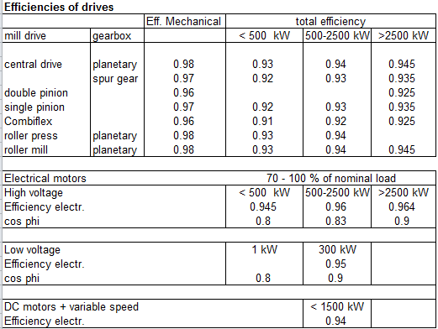

Figure 23: Guide values for the estimation of drive efficiencies (source HTEC data base VA-Datenblatt Fh 09.02.199).

## GV: Cp Values of Gases, Solids and Coal

For reference, here are some cp.

Note, that the HB Excel tool uses polynomial approximations to calculate the cp as a function of temperature and composition of the material.

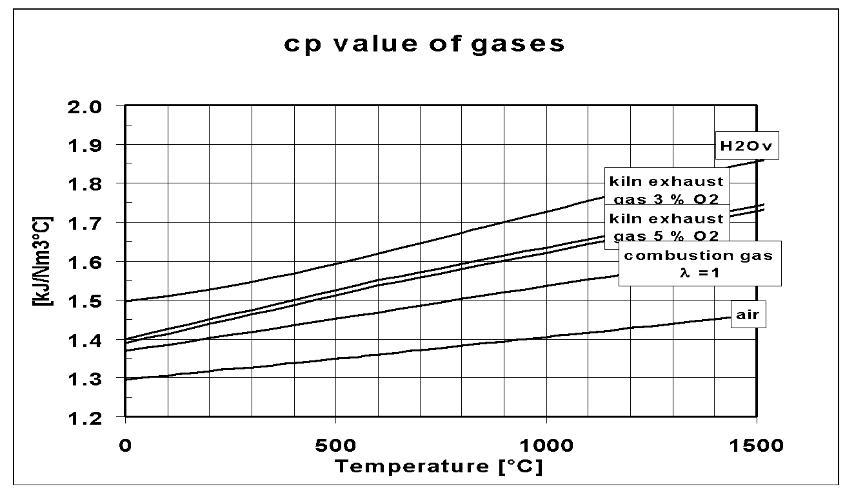

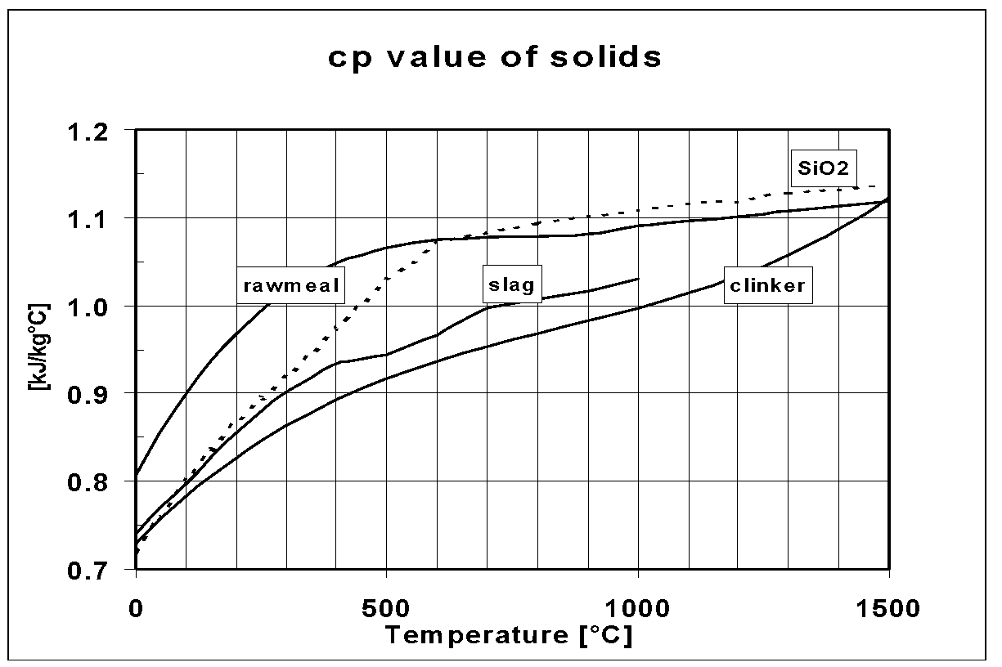

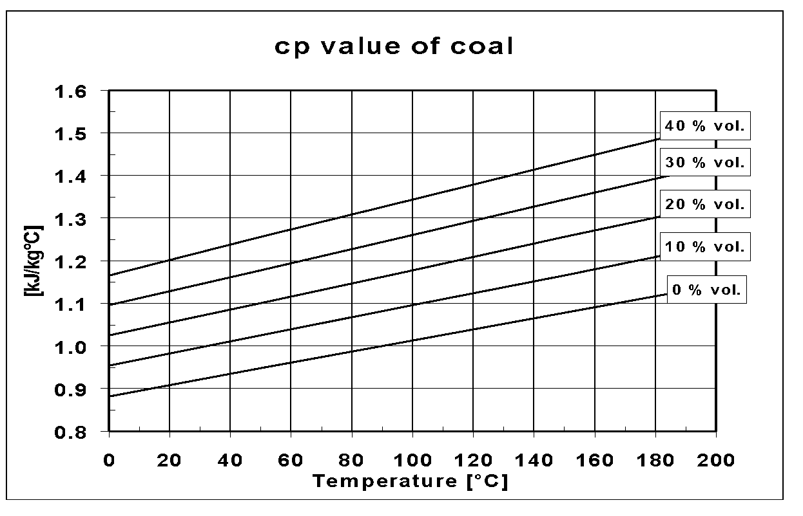

## Flowcharts of 2 and 3-fan systems

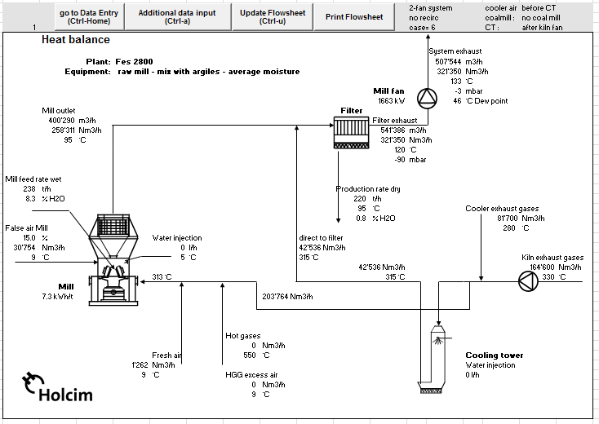

Figure 24: VRM 2-fan system.

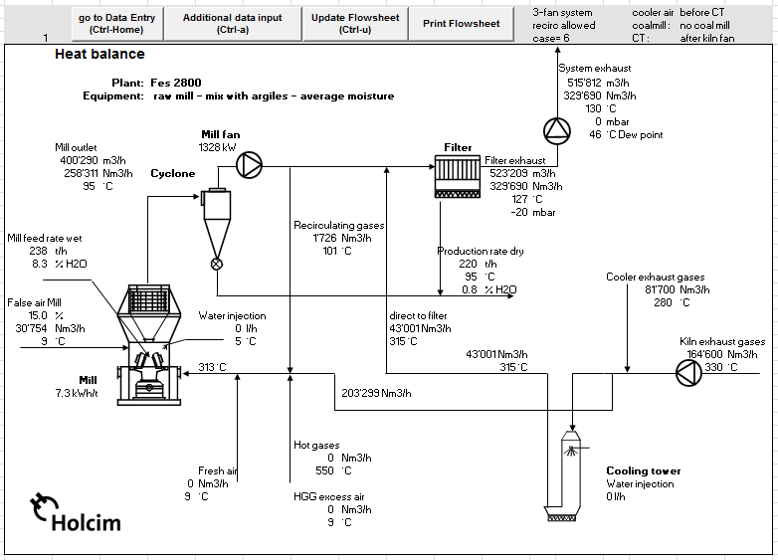Figure 25: VRM 3-fan system.

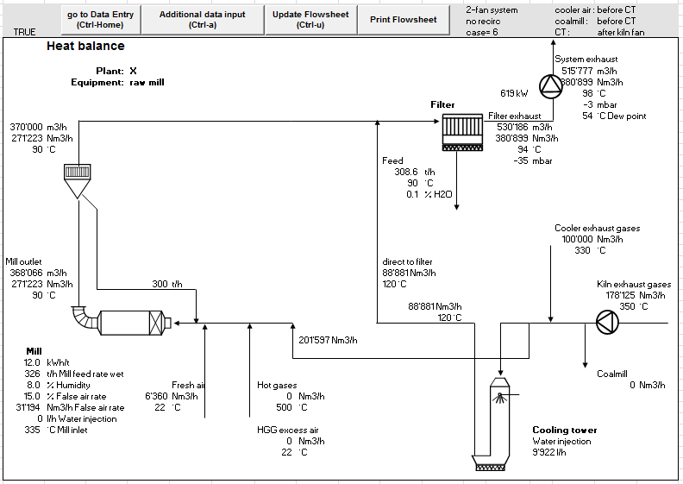

Figure 26: BM (air-swept) 2-fan system

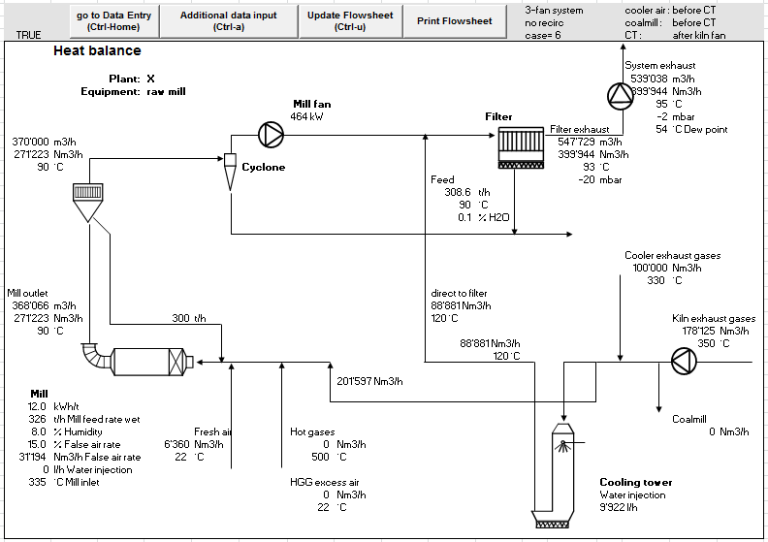

Figure 27: BM (air-swept) 3-fan system

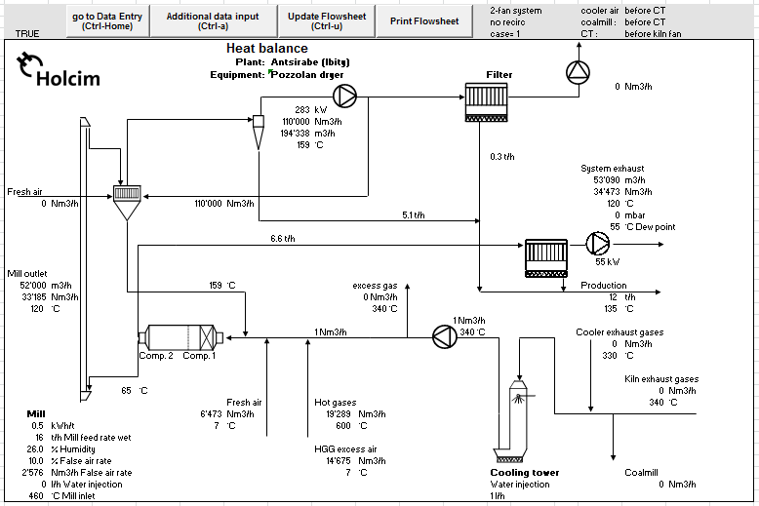

Figure 28: BM (end discharge), 2-fan system. The two fans are marked with a red circle.  
The three fan system is not programmed. It would have a cyclone and another fan between the mill and the mill filter, as well as a recirculation line.



|  |  |  |
| --- | --- | --- |
|  | **Legal Company Name** |  |
|  | Road Name 123-456  City, Postal Code0  Country Name  info@companyname.com  www.companyname.com  Phone +12 34 567 89 00  Fax + 12 34 567 89 01 |

